Citizens Association Newsletter FALL 2008

Property Management People
82A Wormans Mill Court
Frederick, MD 21701
(800) 336-8009
Fax (301) 694-9514

Community Manager
Renee Hall x 1023
Renee.ah@pmpbiz.com

PMP Office Hours
M-F 9:00 a.m. to 5:00 p.m.

www.pmpbiz.com

Next Regular Board Meeting…

…Is scheduled for Monday, October 6, 2008 at the Jefferson County School Board Office at 110 Mordington Ave, Charles Town, WV. The Board will be formally approving the 2009 contracts, approving the 2009 assessment rate, and approving the 2009 budget.
Your 2008 Board of Directors:

Gary Kable « President

Jud Romine « Vice President

Phil Larcomb « Treasurer

Bob Tansill « Secretary

Carol Hartzell « Member at Large

CITIZENS MEETING
Tuscawilla Hills Citizens Association
October 13, 2008
South Jefferson Elementary School
Summit Point Rd., Summit Point

- Reading of last Citizen Meeting Minutes
- Treasurers Report
- Management Co. Report
- Delinquent Road fund Report
- Committee Reports
  - Parks and Recreation - Bob Tansill
  - Garden Club – Doris Walsh
  - Grounds and Roads
  - Covenants – Gary Kable
  - Nominations Committee
- 2009 Assessments & Budget
- Open Forum Residents
- Adjournment

Visit the Community Website at: www.tuscawillahills.org.



Budget Time

Contracts are being reviewed, proposals have been requested, the reserve study is being reviewed and the budget is being prepared at this time.

Come to the next meeting if you would like to know more!

Park Concerns

Over the years Tuscawilla has generously opened up the soccer field and the park to support youth activities. Mostly, this has not been a problem but the problems appear to be escalating as more and more people seem to think the use of parks is a right instead of a privilege.

Car volume, parking in the grass, rude behavior to neighboring homeowners, parking in the neighbors yards, burning of the trash cans, litter, property damage, not sharing the basketball courts, foul language, drinking alcohol, sexual activity – THIS BEHAVIOR WILL NOT BE TOLERATED

The parks are for TUSCAWILLA RESIDENTS ONLY and the rules apply to everyone. No outside use is permitted unless given written permission by the Board of Directors. Locust Hill residents should not be using our parks for activities or entertainment.

Please respect the rules, your neighbors and your community property. If a situation arises, talk to the coach of the team practicing, talk to your teenagers and stress the importance of their help and cooperation in abiding by the rules and the respect required to use these facilities. Continued problems may result in closure of the parks to teams and residents. If you believe outsiders are using the park without permission, call the police. Protect your community!

2008 Road Repair Project

The first phase of road repairs that is part of a three year project will begin next week in Tuscawilla Hills.


Requests for Proposals were sent out to four paving contractors for the 2008 Capital Reserve Road Repair Project. After much review, two revisions, and more review, the Board is pleased to announce the project was awarded to US Paving LLC.

The streets that will be addressed in 2008 are:

Packet Drive 1941 sq. yards
Sunlite Drive 890 sq. yards
Durham Ct. 728 sq. yards (entire court)
Standish Ct 1051 sq. yards (entire court except parking)
Auburn Ct 982 sq. yards (to complete the court)
And two additional areas on Lindsey Dr. near the intersections of New Castle (26 sq yds) and Carroll Dr. (53 sq yds)

The total project is $81,390 and will be paid from the Capital Reserve Fund. Work will be performed in accordance with the contract that is to repair sub-base failures and apply a 1.5 in compacted depth overlay to the designated areas. Milling of edges and feathering of driveway aprons will be done to create a finished look and a smooth transition.

Work will begin on Tuesday, October 1, 2008, and the entire project will take approximately 14 days to complete. The first street scheduled is Sunlite Dr. The remainder of the streets will follow. Traffic impact will be kept to a minimum in that no roads will be closed or inaccessible, EXCEPT Standish Ct. that will require vehicles to be parked elsewhere during paving. For this reason, Standish Ct paving will be complete on Thursday, October 2, 2008. Residents on that street will receive a letter with instructions.

During this time, through traffic should use Tuscawilla Dr rather than Packet or Sunlite if at all possible until each street is complete. If there are cars parked on any of the designated streets when the work begins, the car will be towed, without prior notice, at the owner’s expense. If your vehicle is towed, please contact Cody’s Salvage at 304-725-8507.

The Board and PMP appreciate your cooperation and patience during this project. Please call Renee’ Hall at PMP 301-694-6900 x-1023 if you have any questions.

REMINDER

NON REGISTERED MOTORIZED VEHICLES (SCOOTERS, MOPEDS, SKATEBOARDS, ATV’S)

Anything that is not a registered and properly inspected vehicle is strictly prohibited from being driven on the streets or common areas within Tuscawilla Hills. Your cooperation is appreciated.



Be on Alert

Locust Hill experienced vehicle break in’s in the past couple of weeks. While nothing has been reported in Tuscawilla Hills that we are aware of, please remember to park your vehicles in your garage where possible, do not keep valuables in your car, make sure the windows are up and the doors are locked at night.

If you see suspicious activity, please contact the police or sheriff’s department right away.

Tuscawilla Hills Leash Law Reminder


Tuscawilla Hills has a leash law that is supported by Jefferson County Animal Control Department. Any dog caught running loose can be picked up and taken to the animal shelter. It will cost the owner $100.00 to retrieve their animal. Residents are also asked to clean up after their pets when you take them on a walk.

ANIMAL WASTE PICK UP
As always, it is courteous, responsible and a matter of health safety, to pick up after your pet when out on a walk. But have you checked the back yard lately? Animal waste should be removed from your yard on a regular basis as a matter of health and as a courtesy to your neighbors. Everyone is busy, but please…be a good neighbor!

Property Management People is pleased to announce that the Frederick office will be moving to the following location effective Monday, September 29, 2008:
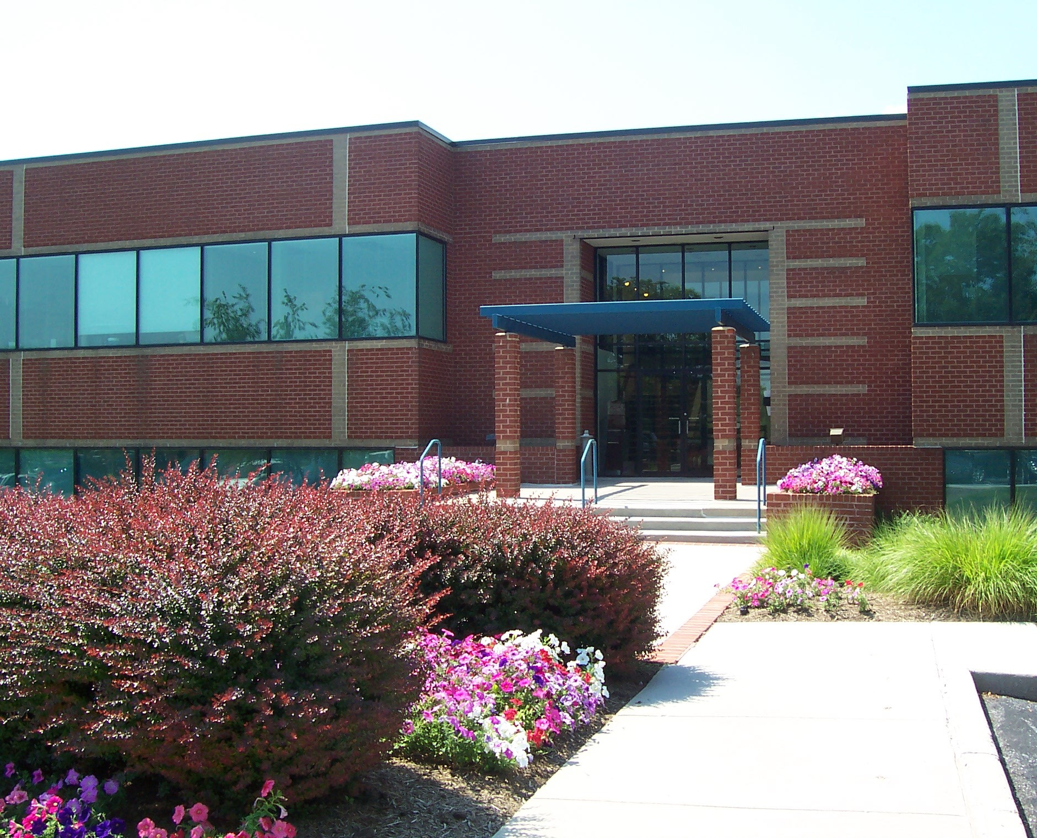

Property Management People, Inc.
92 Thomas Johnson Drive, Suite 170
Frederick, MD 21702

Please direct all future correspondence to this address!
Telephone and fax numbers and e-mail addresses are unchanged.


ATTENTION: Homeowners!

Interested in serving on the Board or a Committee.

Positions are available for 2009

Please contact Property Management People for more information on how you can help in your community at 301-694-6900 x-1023 or email renee.ah@pmpbiz.com.



Put your costumes on, decorate the yard, set up the haunted house and get the cauldron bubbling in the front yard. Halloween will be here before you know it and enthusiasts, both young and not so young, will be darting about the community in search of tricks and treats.

Halloween falls on Wednesday this year and the Trick or Treat time has been scheduled from 6:00 to 8:00 P.M. on Friday, October 31, 2008. All trick or treaters should be off the streets by 8:30 P.M.






FALL YARD CLEAN UP!

Back by popular demand – Roll off containers will be provided for yard waste. Last year’s project was a huge success and we hope for even more participation this year.

Containers will be accessible on Saturday, November 22nd & Sunday, November 23rd. Please mark your calendar and arrange to haul your yard waste to these containers on one of the days indicated.

Acceptable yard waste are things like broken limbs, bush trimmings, grass clippings, weeds, unpainted wood, including all those stacked piles that are all over the neighborhood that no one seems to use from year to year, old mulch and of course LEAVES!!!

Please keep in mind that these containers cannot contain anything but yard waste. That means…

NO
- paint or oil
- furniture
- plastic
- trash
- appliances
- household cleaners
- batteries
- tires, etc.

If you have other items that you need to get rid of, Apple Valley Waste will pick up two items per week so long as it can be picked up by one person and is not a hazardous waste product, such as paint, oil or things that can explode under pressure. They will even pick up larger items if you call in advance. Call Apple Valley Waste today at 304-304-267-1280 to get the details.

